**ST. XAVIER’S COLLEGE**

**MAITIGHAR, KATHMANDU**



**COMPUTER GRAPHICS**

**LAB ASSIGNMENT #7**

**Submitted by:**

NARAYAN PANTHI

013BSCCSIT024

**Submitted to:**

Er. Anil Sah

Department of Computer Science

St. Xavier’s College

Maitighar, Kathmandu

# TRANSLATE THE IMAGE :

# SOURCE CODE:

|  |
| --- |
| #include <vcl\vcl.h>  #pragma hdrstop  #include "NEWWWWW.h"  //---------------------------------------------------------------------------  #pragma resource "*.dfm"  TForm1 *Form1;  int Tx,Ty,i,j,a,b,x,y;  //---------------------------------------------------------------------------  __fastcall TForm1::TForm1(TComponent* Owner)  : TForm(Owner)  {  }  //---------------------------------------------------------------------------  void __fastcall TForm1::Button1Click(TObject *Sender)  {  Tx=StrToInt(Edit1->Text);  Ty=StrToInt(Edit2->Text);  x=Image1->Height;  y=Image1->Width;  for (i=0;i<=x;i++)  {  for (j=0;j<=y;j++)  {  a = i+Tx;  b = j+Ty;  Image2->Canvas->Pixels[a][b]=Image1->Canvas->Pixels[i][j];  }  }  } |

# OUTPUT:

# BEFORE:

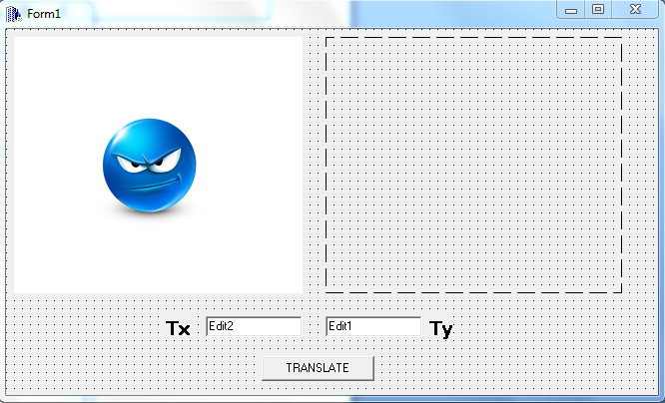

# AFTER:

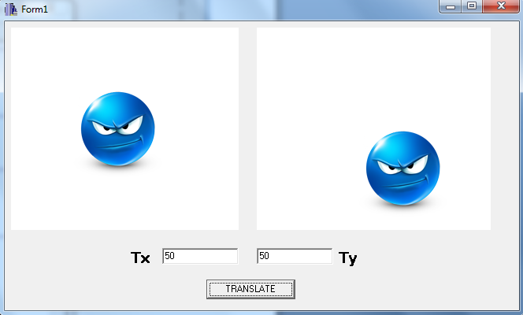

# SCALE THE IMAGE :

# SOURCE CODE:

|  |
| --- |
| #include <vcl\vcl.h>  #pragma hdrstop  #include "NEWWWWW.h"  //---------------------------------------------------------------------------  #pragma resource "*.dfm"  TForm1 *Form1;  int TxX,TyY,i,j,a,b,x,y;  //---------------------------------------------------------------------------  __fastcall TForm1::TForm1(TComponent* Owner)  : TForm(Owner)  {  }  //---------------------------------------------------------------------------  void __fastcall TForm1::Button1Click(TObject *Sender)  {  TxX=StrToInt(Edit1->Text);  TyY=StrToInt(Edit2->Text);  x=Image1->Height;  y=Image1->Width;  for (i=0;i<=x;i++)  {  for (j=0;j<=y;j++)  {  a = i*TxX;  b = j*TyY;  Image2->Canvas->Pixels[a][b]=Image1->Canvas->Pixels[i][j];  }  }  } |

# OUTPUT:

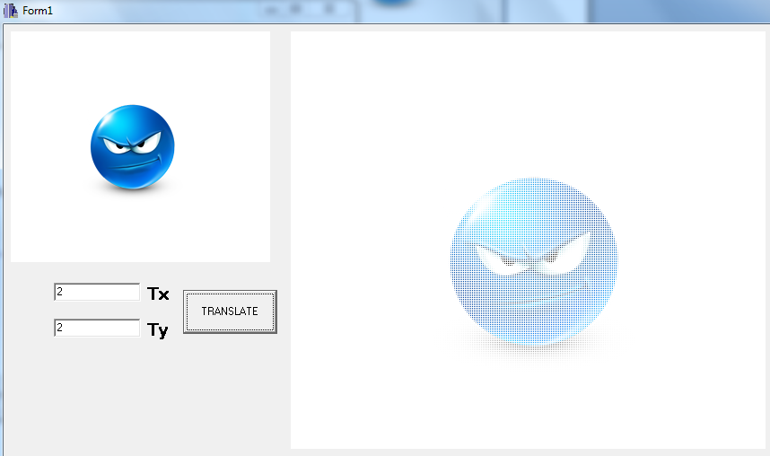

# ROATATION OF THE IMAGE:

|  |
| --- |
| #include <vcl\vcl.h>  #pragma hdrstop  #include <math.h>  #include "Unit1.h"  //---------------------------------------------------------------------------  #pragma resource "*.dfm"  TForm1 *Form1;  int x,y,rot,a,b,i,j;  void __fastcall TForm1::Button1Click(TObject *Sender)  {  x=Image1->Height;  y=Image1->Width;  rot=StrToInt(Edit1->Text);  for(i=0;i<=x;i++)  {  for(j=0;j<=y;j++)  {  a=i*cos(rot)-j*sin(rot);  b=j*cos(rot)+i*sin(rot);  Image2->Canvas->Pixels[a][b]=Image1->Canvas->Pixels[i][j];  }  }  } |

# OUTPUT:

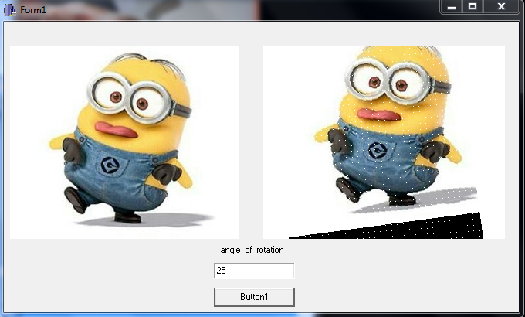

# ALL

|  |
| --- |
| //---------------------------------------------------------------------------  #include <vcl\vcl.h>  #pragma hdrstop  #include "APPLE.h"  #include <math.h>  //---------------------------------------------------------------------------  #pragma resource "*.dfm"  TForm1 *Form1;  int Tx,Ty,i,j,a,b,x,y;  int TxX,TyY,rot;  //---------------------------------------------------------------------------  __fastcall TForm1::TForm1(TComponent* Owner)  : TForm(Owner)  {  }  //---------------------------------------------------------------------------  void __fastcall TForm1::TRANSLATEClick(TObject *Sender)  {  Tx=StrToInt(Edit1->Text);  Ty=StrToInt(Edit2->Text);  x=Image1->Height;  y=Image1->Width;  for (i=0;i<=x;i++)  {  for (j=0;j<=y;j++)  {  a = i+Tx;  b = j+Ty;  Image2->Canvas->Pixels[a][b]=Image1->Canvas->Pixels[i][j];  }  }  }  //---------------------------------------------------------------------------  void __fastcall TForm1::SCALEClick(TObject *Sender)  {  TxX=StrToInt(Edit3->Text);  TyY=StrToInt(Edit4->Text);  x=Image1->Height;  y=Image1->Width;  for (i=0;i<=x;i++)  {  for (j=0;j<=y;j++)  {  a = i*TxX;  b = j*TyY;  Image3->Canvas->Pixels[a][b]=Image1->Canvas->Pixels[i][j];  }  }  }  //---------------------------------------------------------------------------  void __fastcall TForm1::ROTATEClick(TObject *Sender)  {  x=Image1->Height;  y=Image1->Width;  rot=StrToInt(Edit5->Text);  for(i=0;i<=x;i++)  {  for(j=0;j<=y;j++)  {  a=i*cos(rot)-j*sin(rot);  b=j*cos(rot)+i*sin(rot);  Image4->Canvas->Pixels[a][b]=Image1->Canvas->Pixels[i][j];  }  }  } |

